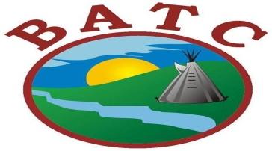
Job Opportunities Competition #0120-89

Land To Life Trainees
Atoskewin Success Centre
(10) Full Time Term Positions

THE POSITION:

As part of BATC Employment & Training, the Land to Life Trainees are committed to assisting, developing, and implementing community-based education and cultural programs which focus on the needs of the communities.
This position will be based out of the Atoskewin Success Centre and will report to the Program Manager and Office Manager.

DUTIES AND RESPONSIBILITIES:

- Assist in implementing askīy wīcihisowin (Land to Life) curriculum
- Works directly with Elders and Project Coordinators to deliver communities activities: such as netting fish, animal preparation, protocols, etc.
- Assist with setup and scheduling of Land Based Learning activities
- Comfortable and capable of working in indoor and variable outdoor conditions.
- Understanding of indigenous communities and have personal involvement with culture and language or wanting to work with LAND TO LIFE
- Work closely with Personal Development Coaches in our BATC communities and Atoskewin Success Centre assisting in developing programs and services.

QUALIFICATIONS:

- Must be First Nation
- Ages 15 – 30 years old
- Have not participated in any other Youth Employment and Skills Strategy program (Agricultural Youth Green Jobs Initiative and/or Career Focus program)
- MUST HAVE CPIC (CRIMINAL RECORDS CHECK) AND VULNERABLE SECTOR CHECK
- Minimum Grade 8, or other training program in First Nations Culture (e.g. First Nations life skills programs, substance abuse healing programs, traditional counseling strategies such as talking circle, medicine wheel).
- Experience of Traditional or cultural knowledge
- Good communication skills, speak Cree an asset
- Self-motivated with the ability to work independently and as a team.
- Comfortable and capable of working in indoor and variable outdoor conditions.
- A valid driver’s license is required.

Closing date: October 1st, 2021 - Please quote Competition # 0120-97
Please submit RESUME, COVER LETTER AND CPIC to:

Human Resources Phone: 306-446-1400
Battleford Agency Tribal Chiefs
1282 101st Street Email: humanresources@batc.ca
North Battleford, Saskatchewan S9A 1K3

