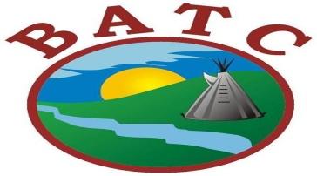

Job Opportunities Competition # 0120-99
BATC Employment & Training
Arena Worker Trainees
Three (3) Temporary Term Positions
Moosomin First Nation

THE POSITION:
Under the direction of the Personal Development Coach of BATC Employment & Training, the Arena Worker will be responsible for specific tasks in the arena. This is a term position based out of Moosomin First Nation.

DUTIES AND RESPONSIBILITIES:

- Janitorial duties in all public areas, including bathrooms and bleachers;
- Shovel sidewalks ad entrances of the arena;
- Operation and maintenance of ice plant and Zamboni;
- Ensure all bathroom supplies are in the bathrooms;
- Empty all garbage consistently through-out the day or at the end of the day;
- Go out and put all garbage bags into garbage bins at the end of the day or shift;
- Assist in ordering supplies such as garbage bags, janitorial supplies with the Band Designate;
- Wipe down all areas such as windows, walls daily;
- Enforcement of arena rules;
- Clean area mezzanine daily;
- Establish and maintain a good communication with Band Designate, or designates, food vendors and arena staff;
- Other duties as assigned

Record Keeping:
- Provide written incident reports to immediate supervisor
- Maintain an inventory of supplies and equipment;
- Submit timesheets and leave forms to immediate supervisor

QUALIFICATIONS
- Must be youth between the ages of 18-64 and on Income Assistance residing on Moosomin First Nation;
- Willingness to work as a team member with BATC staff;
- Must be willing to sign an Oath of Employment and abide by a Code of Ethics
- Ability to work in scheduled hours; evenings and/or weekends
- MUST HAVE CPIC

Closing Date: October 8, 2021 by 4:30 pm – Please Quote Competition # 0120-99

Please submit Resume, Cover Letter and CPIC to:

Human Resources Phone: 306-446-1400
Battlefords Agency Tribal Chiefs
1282 101st Street
North Battleford, SK S9A 0Z8 Email: humanresources@batc.ca

