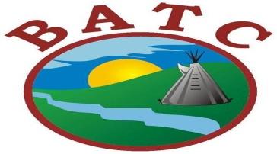

Job Opportunities Competition # 0120-98
BATC Personal Development Coach
Moosomin First Nation
(1)Temporary Full Time
THE POSITION
The BATC Personal Development Coach will be responsible to assess Social Assistance clients seeking employment. Under the direction of the PDC Manager, the Personal Development Coach will advocate and mediate for client personal and social development. The BATC Personal Development Coach will work out of the BATC Community Services office on Moosomin First Nation.
DUTIES AND RESPONSIBILITIES:
- Assess Income Assistance Clients, and determine if employable.
- Build a mandatory case plan; utilizing employment and training programs, counselling services, NCB staff, Placement and other community resources.
- Maintain case file, update database, authorize incentives, refer, and support clients.
- Continue active contact and follow up with mandatory case clients, determines if client is adhering to plan.
- Intervene and liaise with Social Assistance administrator for client eligibility.
- Provide updates and reports: number of clients assessed, clients applied/completed training, clients referred to Placement, follow-up, clients faltering from mandatory plan.
- Advocate and mediate for client personal and social development.
- Work as team with Social Development Staff
- Adhere to BATC Personnel Policy and regulations
- Other duties as directed by PDC Manager
QUALIFICATIONS:
- The ideal candidate will be Post-Secondary Certified or with experience in case management. Consideration will be made for applicants with related technical post-secondary certification, plus extensive work experience.
- Extensive knowledge and experience working with computer software applications on a daily basis
- Experience with data base an asset
- Valid Drivers License
- Speak Cree or Saulteaux an asset
EMPLOYMENT TERMS:
- This position will be a term employment contract (ending March 31, 2022)
- The position will be subject to an initial six (6) month probationary period and annual performance evaluation.
- Extensive travel and report to BATC main office on a weekly basis.

Closing date: October 7, 2021 - Please quote Competition # 0120-98
Please submit resume, cover letter, Drivers Abstract and CPIC to:

Human Resources Phone: 306-446-1400
Battleford Agency Tribal Chiefs
1282 101st Street Email: humanresources@batc.ca
North Battleford, Saskatchewan S9A 0Z8

